FireStorm GDD

|  |  |
| --- | --- |
| **1.0** | **Introduction/Overview** |
| **1.1** | **Objectives** |
| **1.3** | **UI** |
| **2.0** | **Concept Art for In-Game** |
| **2.1** | **Concept Art for UI** |
| **2.2** | **Music/SFX** |

1. **Introduction/Overview**

Firestorm is a game in which the player plays a character that needs to escape from a place your kidnappers have put you to keep you, the player needs to escape and survive, the player will have the choice to fight the final boss of the evil crew that took you or if the player is just going to leave and finish the game that way, every area in Firestorm player will have a boss as well to get to the next area and closer to the final boss.

* 1. **Objectives**

There aren’t many objectives other than fight the evil men and some of their bosses for your escape and maybe even the final boss to get to safety

**1.3 UI**

In the UI section of the game will be pretty simple a normal main menu in which the player can click ”Play Game” which will bring the player to the game and also an exit button to leave the game when the player is done playing the game, In game the player will be able to pause the game in which the player can either continue the game or exit, the health bar refill overtime

**2.0 Concept Art for In-Game**

**MAIN CHARACTER**

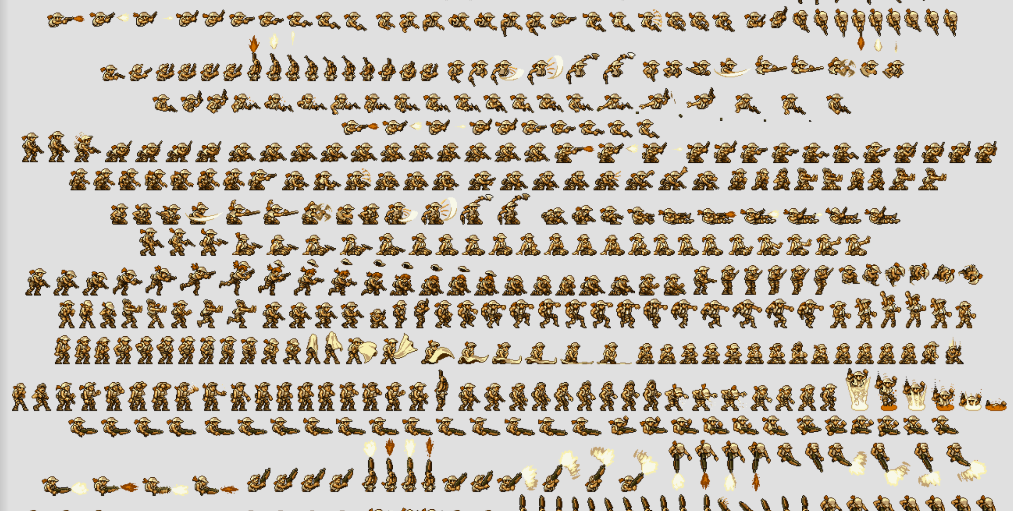

**ENEMIES**

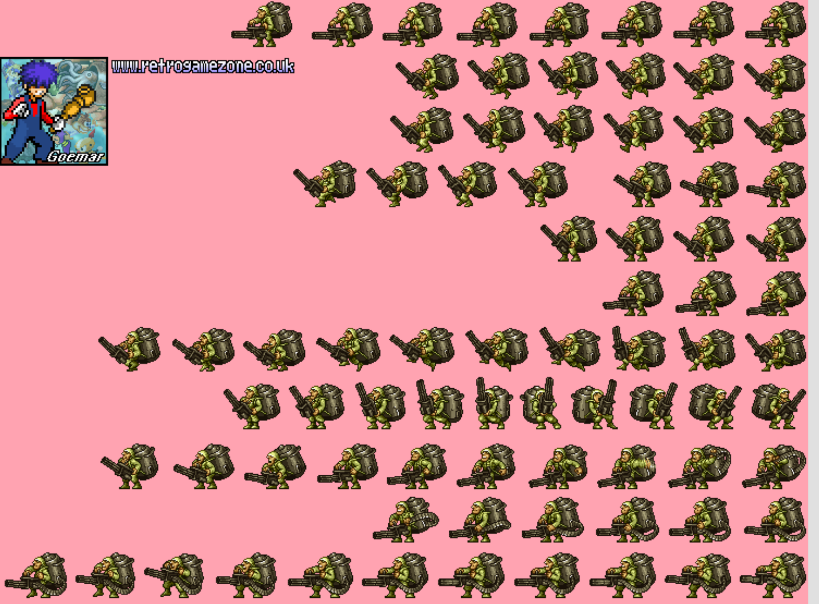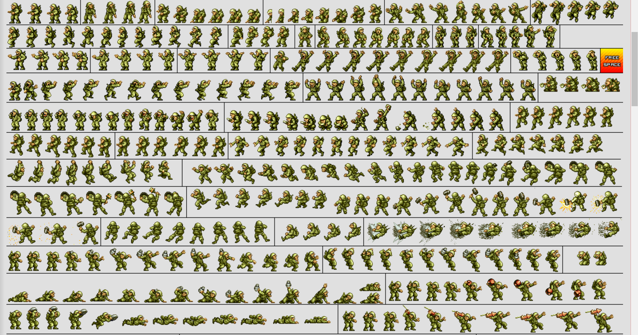

**BOSSES**

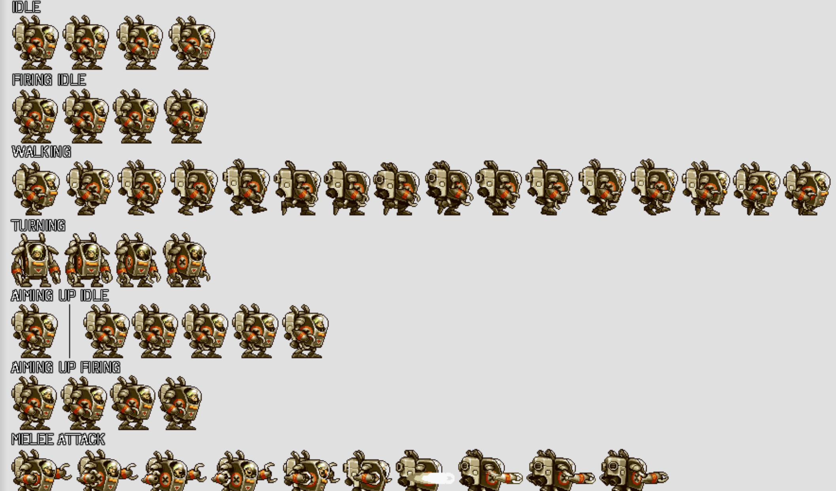

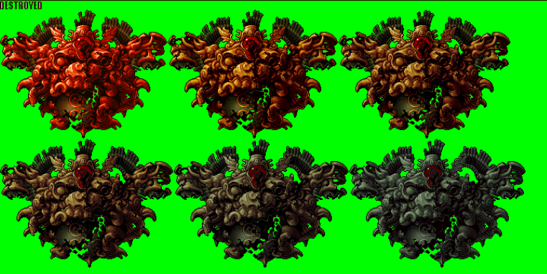

**BACKGROUND**

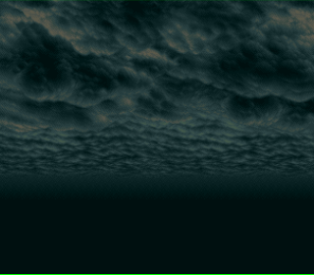

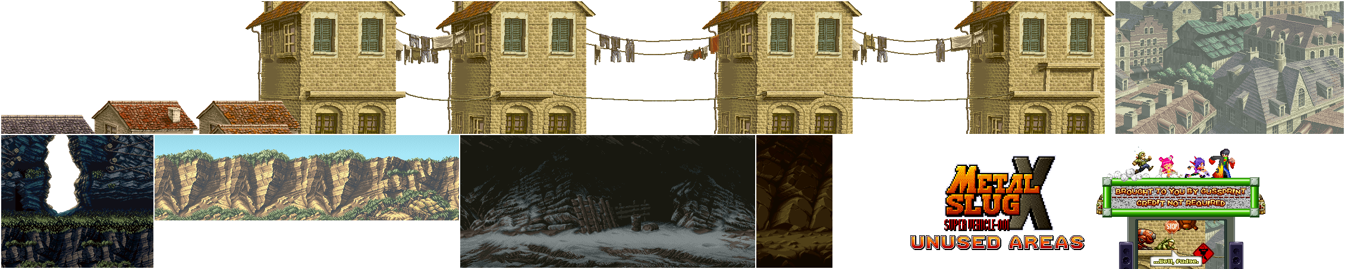

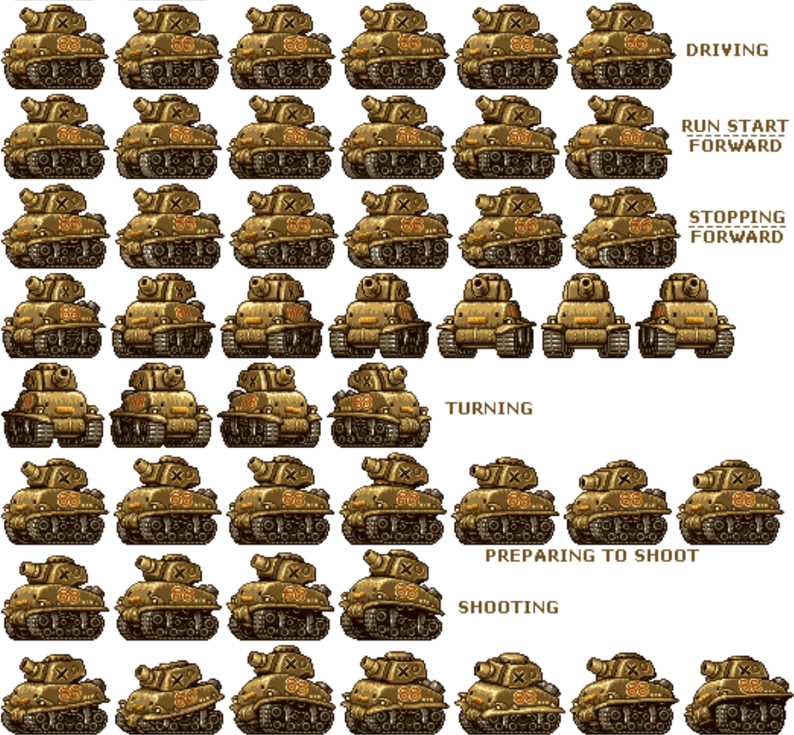

**HUD**

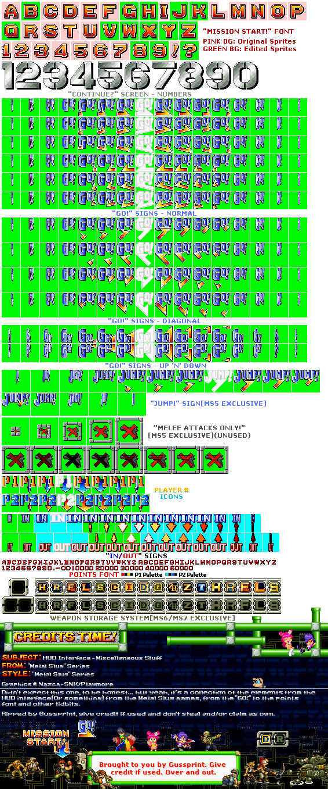

**2.1 Concept Art for UI**

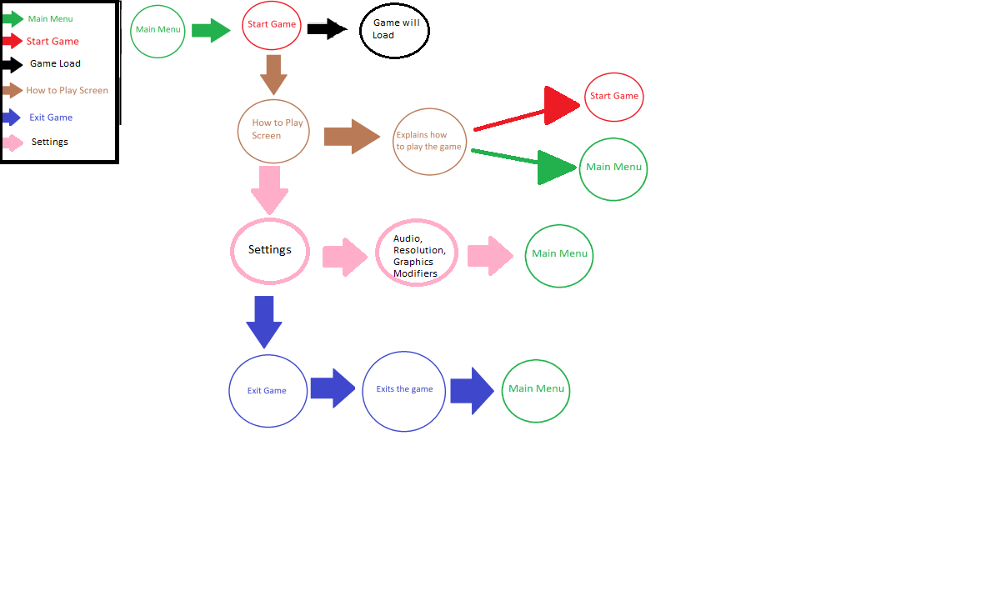

**2.2 music/SFX**

The music will be a catchy song and the feel to the game de to the music will be intense and should make the player feel like something or someone will show up real soon to fight them